Advanced Data Visualization for Strategic HR Decisions

Data Description
EmpID | Employee ID
Age | Age of the employee
AgeGroup | Age group to which the employee belongs
Attrition | Employee attrition status (whether the employee has left the organization or is still active)
BusinessTravel | Frequency of business travel for the employee
DailyRate | Daily rate of pay for the employee
Dateofjoining | Date of Joining Company
Dateofliving | Date of living company
Department | Department in which the employee works
DistanceFromHome | Distance in miles from the employee’s home to the workplace
Education | Level of education attained by the employee
EducationField | Field of education of the employee
EmployeeCount | Number of employees
EmployeeNumber | Unique identifier for each employee
EnvironmentSatisfaction | Employee’s satisfaction level with the work environment
Gender | Gender of the employee
HourlyRate | Hourly rate of pay for the employee
JobInvolvement | Employee’s level of job involvement
JobLevel | Level of the employee’s job position
JobRole | Role of the employee within the organization
JobSatisfaction | Employee’s satisfaction level with their job
MaritalStatus | Marital status of the employee
MonthlyIncome | Monthly income of the employee
SalarySlab | Categorization of monthly income into salary slabs
MonthlyRate | Monthly rate of pay for the employee
NumCompaniesWorked | Number of companies the employee has worked for in the past
Over18 | Whether the employee is over 18 years old
OverTime | Whether the employee works overtime or not
PercentSalaryHike | Percentage increase in salary for the employee
PerformanceRating | Performance rating of the employee
RelationshipSatisfaction | Employee’s satisfaction level with work relationships
StandardHours | Standard working hours for the employee
StockOptionLevel | Level of stock options granted to the employee
TotalWorkingYears | Total number of years the employee has worked
TrainingTimesLastYear | Number of training sessions attended by the employee in the last year
WorkLifeBalance | Employee’s work-life balance satisfaction level
YearsAtCompany | Number of years the employee has worked at the current company
YearsInCurrentRole | Number of years the employee has been in the current role
YearsSinceLastPromotion | Number of years since the employee’s last promotion
YearsWithCurrManager | Number of years the employee has been working with the current manager

Instructions
You have been provided with a dataset on HR metrics. Your task is to perform an advanced analysis, answer the business questions below, and design a dynamic dashboard that supports “what-if” analysis for senior management decision-making.

Business Questions
- Employee Attrition Risk Modeling
- Visualise attrition trends over time (at least 5 years, derived from dates).
- Segment attrition by department, job role, tenure, performance, and salary slab.
- Identify attrition risk clusters (e.g., employees most likely to leave in the next 12 months based on combinations of variables).
- Recommend targeted interventions for each high-risk segment.
- Employee Engagement & Productivity Index
- Create a composite “Engagement Index” combining JobSatisfaction, EnvironmentSatisfaction, RelationshipSatisfaction, and WorkLifeBalance.
- Correlate this index with productivity measures (performance ratings, promotions, overtime hours, etc.).
- Identify “silent quitters” — employees with high tenure but declining engagement and productivity.
- Recommend strategies for early intervention.
- Diversity, Inclusion & Pay Equity
- Visualise gender, education field, and marital status diversity by job level and department.
- Create a pay equity heatmap comparing performance vs. salary across gender and job roles.
- Track diversity evolution across years, highlighting areas of stagnation.
- Suggest initiatives for inclusive growth and equitable compensation.
- Performance, Career Progression & Compensation Alignment
- Compare performance ratings with salary hikes, promotions, and stock options.
- Visualise career progression paths (YearsSinceLastPromotion vs. Performance vs. Compensation).
- Identify departments/roles with the highest mismatch between performance and rewards.
- Recommend a data-driven career progression policy.
- Training & Development ROI
- Analyse impact of training sessions on performance improvement over time.
- Build a department-level training ROI dashboard linking investment (training times, promotions, performance gains).
- Identify employees with high training hours but stagnant performance.
- Propose an optimized training strategy aligned with business outcomes.
- Predictive “What-If” Scenarios (Stretch Goal)
- Create interactive scenarios (e.g., “What happens if attrition rises by 10% in the Sales department?”).
- Show possible impacts on costs, productivity, and workforce composition.
- Recommend proactive HR policies based on these predictive simulations.

Deliverables
- Interactive Dashboard
- Multi-layered dashboard with drill-downs, filters, and scenario simulations.
- Use at least 5 advanced visualization types (heatmaps, cohort analysis, scatter matrix, decomposition tree, funnel, etc.).
- Include a “What-If Analysis” section for HR scenarios.
- Executive Visual Report (15–20 slides)
- Include advanced storytelling (before/after comparisons, predictive insights, simulations).
- Use visuals that connect insights to strategic business outcomes (cost of attrition, productivity losses, etc.).
- Provide data-backed HR policies and recommendations.

Step 1: Data Preparation
- Check for missing values, duplicates, and outliers (e.g., attrition dates missing for active employees).
- Create derived fields:
  - Tenure = DateOfLeaving – DateOfJoining (for attrited employees) / CurrentDate – DateOfJoining (for active employees).
  - Engagement Index = average of JobSatisfaction + EnvironmentSatisfaction + RelationshipSatisfaction + WorkLifeBalance.
  - Attrition Risk Flag = based on combinations (e.g., Tenure < 2 years, Overtime = Yes, Low JobSatisfaction).
  - Salary Band = categorize MonthlyIncome into slabs (already partially given as SalarySlab).

Basic (Foundational Requirements)
Goal: Demonstrate ability to clean, explore, and visualise data clearly.
Tasks:
- Attrition Trends – Show attrition rate by department, age group, and tenure.
- Engagement Metrics – Visualise satisfaction scores (Job, Environment, Work-Life Balance) by department.
- Diversity Breakdown – Gender and education field distribution across departments.
- Performance vs. Compensation – Compare performance ratings with average monthly income by job role.
- Training Hours – Visualise average training sessions attended per department.
Deliverables:
- A clean and functional dashboard with at least 5 basic visuals (bar, line, pie, stacked column, simple scatterplot).
- A short report (5–7 slides) summarizing descriptive findings.

Advanced (Analytical & Strategic Layer)
Goal: Go beyond description; provide diagnostic insights and connect visuals to business challenges.
Tasks:
- Attrition Risk Segmentation – Use combinations of variables (tenure, salary slab, performance rating, overtime) to identify high-risk groups.
- Engagement Index – Create a composite metric combining Job, Environment, Relationship Satisfaction, and Work-Life Balance; compare across departments.
- Pay Equity Heatmap – Visualise pay vs. performance across gender and job levels.
- Career Progression Gaps – Analyse promotion history vs. performance vs. compensation alignment.
- Training ROI Dashboard – Correlate training sessions with performance improvements and promotions.
Deliverables:
- A multi-layer interactive dashboard with drill-downs and filters.
- At least 3 advanced visualizations (heatmaps, cohort analysis, decomposition tree, scatter matrix).
- A strategic report (10–15 slides) highlighting why trends occur and implications for HR policy.

Stretch (Predictive & Prescriptive Layer)
Goal: Anticipate future scenarios and recommend data-driven HR strategies.
Tasks:
- Attrition Forecasting – Predict potential attrition hotspots for the next year using trends in tenure, salary hikes, and overtime.
- Silent Quitter Detection – Identify long-tenure employees with declining engagement and performance.
- Diversity Pipeline Analysis – Simulate impact of hiring/attrition on gender balance in 3 years.
- Compensation Strategy Simulation – Model impact of different salary hike policies on retention and performance.
- Training Investment Optimization – Recommend department-level training allocations for maximum ROI.
***********************

DVBD Assignment 1
Group Details: | - Shyam Kumar [N002]  - Vedanshi Jha [N039]  - Aadil Khan [N046]  - Vidit Kohli [N051]  - Pratyush Kumar [N052]
Program: MBA Tech CE | Division: C
Date of Experiment: 23-09-2025 | Date of Submission: 06-10-2025
- Data Preparation
  - Data Cleaning & Validation
Step | Action
1 | Removed duplicates based on Employee ID
2 | Checked missing values in key columns
3 | Changed data types (e.g., numeric, text, date)
4 | Standardized categorical values (eg. Yes/ No for Attrition)
5 | Verified date consistency (eg. DateOfJoining ≤ DateOfLeaving)

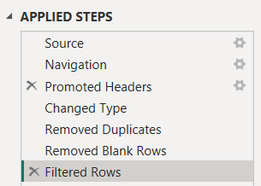
Figure 1. Applied Steps pane in Query Editor, showing history of data transformation steps performed
  - Feature Engineering / Derived Columns
Column Name | Formula | Description
Tenure | 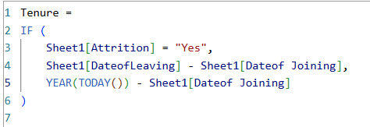 | Employee tenure in years
EngagementIndex | 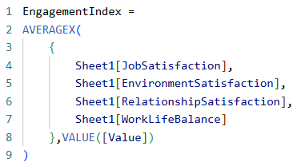 | Composite index for engagement
AttritionRiskFlag | 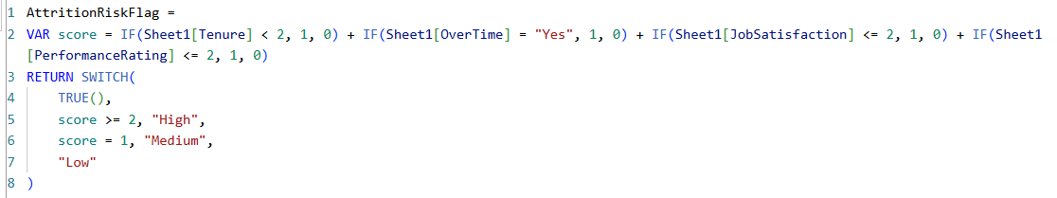 | High-risk employee indicator
SalaryBand | 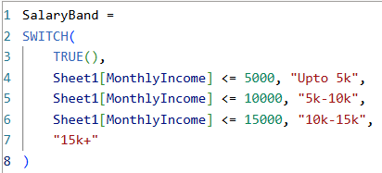 | Used for compensation segmentation
SilentQuitterFlag |  | To identify disengaged long-tenure employees
  - Data Aggregation & Measures
Measure Name | Formula | Description
Attrition Rate | Attrition Rate = count(Sheet1[DateofLeaving])/count(Sheet1[EmpID]) | % of employees who left vs total employees
Avg Performance Rating | Avg Performance Rating = AVERAGE('Sheet1'[PerformanceRating]) | Average performance across roles/departments
Avg Training ROI | Training ROI =  DIVIDE(  Sheet1[AvgPerformance] * Sheet1[AvgSalaryHike],  Sheet1[AvgTrainingSessions]  ) | Derived ratio of performance gain vs training hours
Silent Quitter Flag | SilentQuitterFlag =  IF( Sheet1[YearsAtCompany] > 5 && Sheet1[EngagementIndex] < 2.5 && Sheet1[PerformanceRating] < 4, 1, 0) | Employees who would silently quit
Silent Quitter % | SilentQuitter% =  VAR Total = DISTINCTCOUNT( 'Sheet1'[EmpID] )  VAR Silent = CALCULATE( DISTINCTCOUNT( 'Sheet1'[EmpID] ), 'Sheet1'[SilentQuitterFlag] = 1 )  RETURN  IF( Total = 0, 0, DIVIDE( Silent, Total ) ) | % of employees who would quit silently
Forecasted Attrition Rate | ForecastedAttritionRate = [Attrition Rate] * 1.1 | Trend Projection assumed: 1.1
Predicted Training ROI | Predicted Training ROI = [Training ROI] * 1.05 | Trend Projection assumed: 0.5
SimulatedRetention | SimulatedRetention =  VAR Salary = SELECTEDVALUE('Salary Hike %'[Salary Hike %], 0)  RETURN  [Attrition Rate] * (1 - (Salary / 100) * 0.4) | Estimated employee retention using what-if simulation
Pay Performance Ratio | PayPerformanceRatio =  DIVIDE(  Sheet1[Avg Monthly Income],  AVERAGE('Sheet1'[PerformanceRating])  ) | Ratio of monthly and employee performance
Training ROI | Training ROI =  DIVIDE(  Sheet1[AvgPerformance] * Sheet1[AvgSalaryHike],  Sheet1[AvgTrainingSessions]  ) | Estimated ROI after employee training

- Data Modelling
  - Model Design
Table | Type | Description
Sheet1 | Fact | Main HR metrics table
Calendar | Dimension | Enables trend & forecasting visuals
Salary Hike % | Parameter Table | What-If simulation input for compensation strategy
  - Relationships
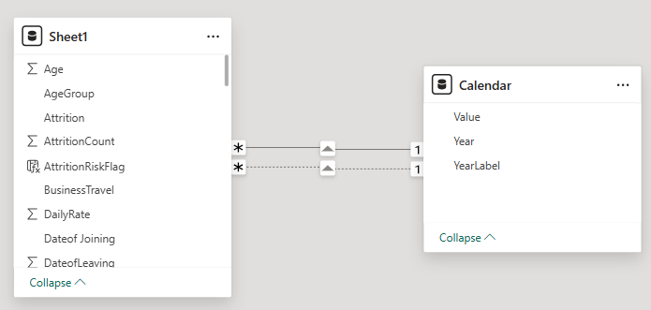

- Dashboard 1: Basic (Foundational Requirements)
  - The first dashboard focuses on descriptive insights, such as understanding historical HR trends, employee engagement, diversity, and performance pattern. It helps HR leaders identify key attrition drivers, monitor workforce balance, and evaluate engagement levels across departments.
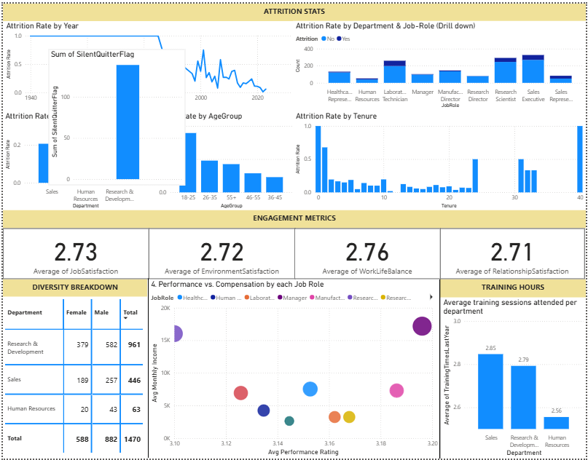

  - Attrition Statistics Section
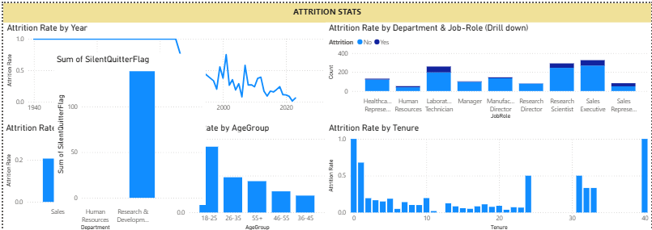
    - This section provides a detailed breakdown of employee attrition patterns across multiple dimensions.
      - Attrition Rate by Year (Line Chart): Highlights overall attrition trends over time, showing whether turnover is increasing or stabilizing.
      - Attrition Rate by Department & Job Role (Clustered Column, Drill-Down): To compare attrition between departments and roles.
      - Attrition by Age Group (Column Chart): Reveals which age demographics experience the highest attrition, supporting age-specific retention and engagement initiatives.
      - Attrition by Tenure (Column Chart): Shows correlation between years of service and attrition likelihood. It is usually higher for early-tenure employees.
      - Silent Quitter Flag (Bar Chart): Displays the number of employees flagged as “silent quitters” (low engagement, high tenure).

    - Engagement Metrics Section
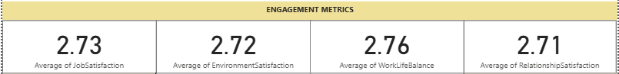
      - KPI Cards (Job, Environment, Relationship, Work-Life Balance): Present department-wide averages of satisfaction scores (1–4 scale). These KPIs help assess workplace morale and identify departments with lower engagement scores that may need intervention.
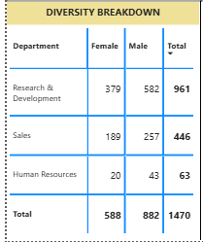
    - Diversity Breakdown Section

      - This matrix visual displays the gender distribution across departments. It provides a quick view of workforce diversity and inclusion balance.

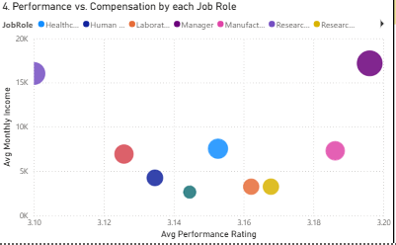
    - Performance vs Compensation Section

      - The scatter plot compares average Monthly Income against Performance Ratings by job role. It helps identify roles where compensation may not be proportionate to contribution, which can inform pay equity adjustments.

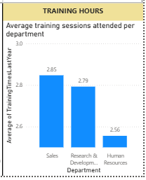
    - Training Hours Section

      - This bar chart shows the average number of training sessions attended per department. It helps HR evaluate learning participation and assess whether training investment is evenly distributed or correlated with higher engagement/performance levels.

- Dashboard 2: Advanced (Analytical & Strategic Layer)

  - The second dashboard focuses on advanced analytics: identifying attrition risk clusters, evaluating pay equity, analysing career progression gaps, and linking training investment with performance outcomes. It provides deeper, data-driven insights that guide HR interventions and strategic workforce planning.

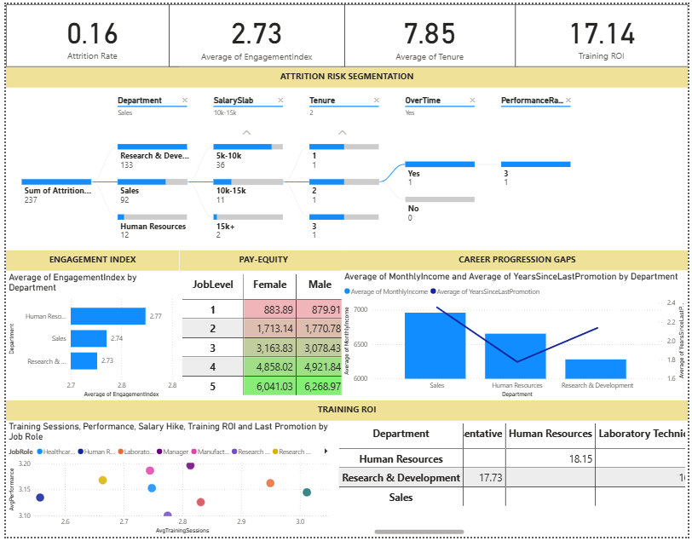
  - KPI Summary
    - 4 KPI cards at top are: Attrition Rate, Average Engagement Index, Average Tenure, and Training ROI.
    - These high-level indicators summarize overall workforce stability, satisfaction, and learning effectiveness, serving as quick reference metrics for leadership.

  - Attrition Risk Segmentation (Decomposition Tree)
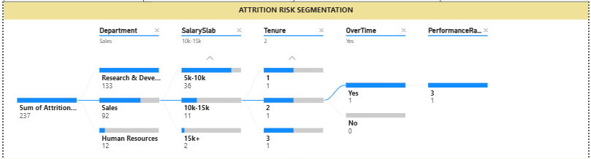
    - This visual breaks down attrition using key variables — Department, SalarySlab, Tenure, Overtime, and PerformanceRating.
    - It helps identify combinations of conditions leading to high attrition risk.
    - The decomposition tree enables drill-down exploration of root causes behind employee exits.

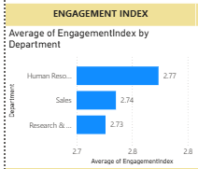
  - Engagement Index by Department

    - Bar chart showing the average Engagement Index across departments.
    - It highlights departments with relatively lower engagement, helping HR prioritize team-level initiatives to improve morale and work culture.

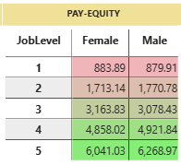
  - Pay Equity (Matrix Table)

    - The matrix table compares average monthly income by gender and job level.
    - It provides visibility into potential pay disparities between male and female employees.

  - Career Progression Gaps (Combo Chart)
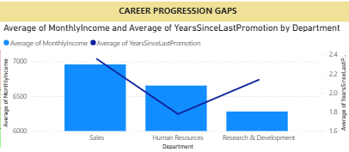
    - The clustered column and line chart compares Average Monthly Income and Years Since Last Promotion by department.
    - This dual-axis chart helps identify departments with high pay but delayed promotions, signalling possible dissatisfaction or stagnation risks among employees.

  - Training ROI (Scatter Plot + Table)
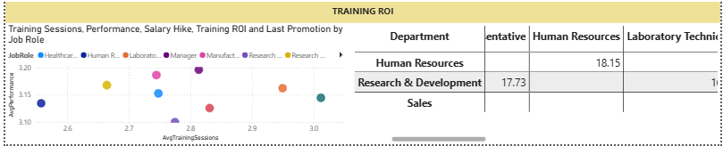
    - The scatter plot correlates training sessions, performance, and salary hike by job role, showing whether higher training participation translates into improved performance or compensation growth.
    - The table summarizes Training ROI by department, helping assess which departments gain the most from training investments.

- Dashboard 3: Stretch (Predictive & Prescriptive Layer)
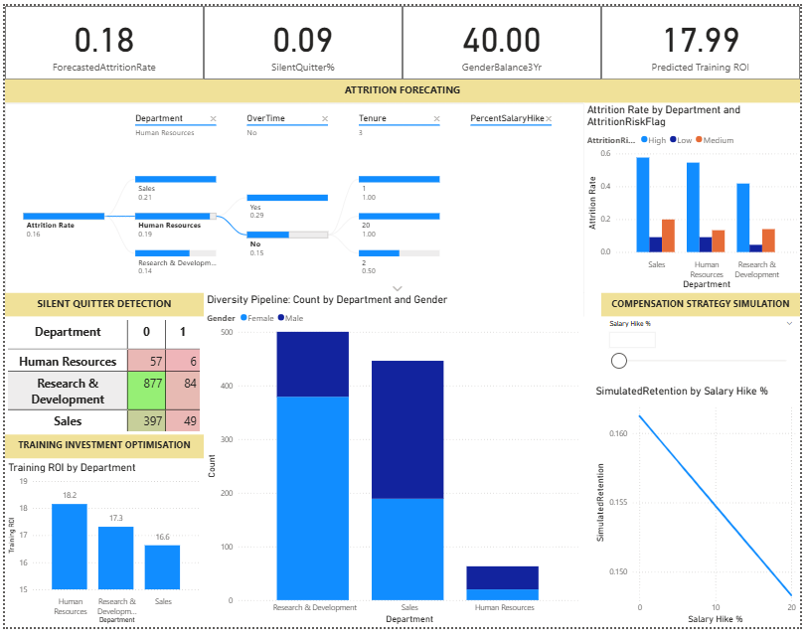
  - This dashboard integrates predictive modelling and scenario simulations to anticipate workforce trends and recommend proactive HR strategies. It focuses on forecasting attrition, detecting disengagement, analysing diversity evolution, and optimizing investments for retention and development.
  - KPI Summary
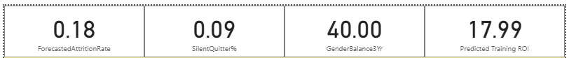
    - The top KPIs are: Forecasted Attrition Rate, Silent Quitter %, 3-Year Gender Balance, and Predicted Training ROI.
    - They provide a snapshot of predicted workforce outcomes. They help management assess overall future risk, engagement levels, diversity sustainability, and expected ROI from HR initiatives.

  - Attrition Forecasting (Decomposition Tree + Bar Chart)
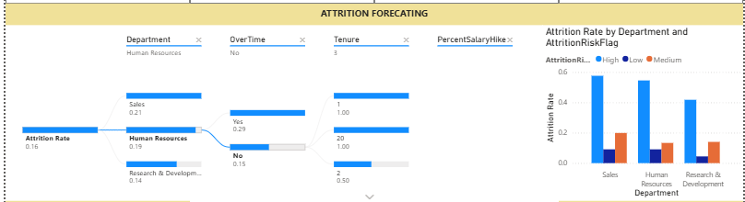
    - The decomposition tree explains attrition drivers using variables like Department, Overtime, Tenure, and Salary Hike.
    - It allows users to drill down to find combinations of factors causing high attrition, while the adjacent bar chart compares attrition rates by department and risk flag (High/Medium/Low), helping prioritize retention focus areas.

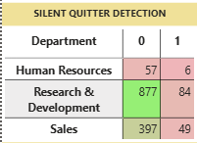
  - Silent Quitter Detection (Matrix Table)

    - This matrix shows the count of silent quitters (low engagement, high tenure) across departments.
    - It enables early identification of disengaged employees.
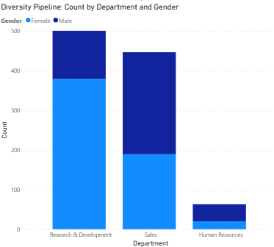
  - Diversity Pipeline (Clustered Column Chart)

    - The gender distribution chart projects workforce diversity over time.
    - It helps visualize how current attrition or hiring trends may affect gender balance in the next three years.

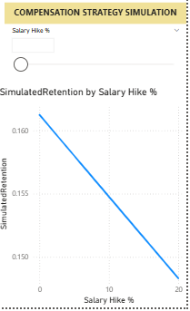
  - Compensation Strategy Simulation (Line Chart + Slider)

    - The Salary Hike % What-If slider and simulated retention line chart demonstrate how changes in salary policy can affect retention rates.
    - This prescriptive tool helps HR leaders test multiple compensation scenarios and identify the most cost-effective salary increment strategy for reducing attrition.

  - Training Investment Optimization (Column Chart)
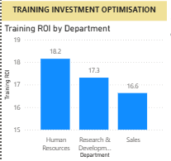
    - The Training ROI by Department visual highlights which departments achieve the highest returns from training programs.
    - It helps HR allocate future training budgets strategically to maximize skill development and overall performance impact.

- Conclusion
Performed advanced analysis on the HR dataset using PowerBI, to answer the business questions transform raw HR data into actionable business intelligence through three progressive dashboards: Descriptive, Analytical, and Predictive–Prescriptive, that supports ‘what-if” analysis for senior management decision-making.

